Contents

IMPORTANT README 2

POS Manager Login 3

Options 3

Launch POS Retail 3

Database Connection 4

Exit 4

Login 4

Reset Password 4

Login 5

POS System (Menu Bar) 5

Options 5

Launch POS Retail 6

Logout 6

Exit 6

Setup 6

Company Information 6

Suppliers 7

Printers 8

Terminals 9

Unit of Measures 11

Denominations 11

View 12

History Log 13

User Management 13

Users 13

Security 15

Stock Management 17

Item Groups 17

Item Master 18

Update Item 20

Promotions 20

Receive Stock 21

Stock Take 22

Point of Sale 22

Sales History 23

Sales Return 23

Shifts 23

Cash Up 24

POS System (Messages) 26

POS System (Sales History Graph) 27

Point of Sale (Retail) 28

POS Main Screen 28

# IMPORTANT README

**PLEASE NOTE THAT THIS IS NOT A FULLY FUNCTIONAL POINT OF SALE SYSTEM READY FOR PRODUCTION. THIS IS A PROOF-OF-CONCEPT ILLISTRATING ALL THE FEATURES A POS SYSTEM WOULD INTAIL AND HOW IT CAN BE USED IN A CUSTOMIZABLE ENVIORMENT. CERTAIN FEATURES ARE NOT FULLY OPERATIONAL.**

# POS Manager Login

## Options

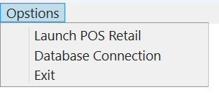

### Launch POS Retail

This will open the Point of Sale program which will run at the terminal in front the store

### Database Connection

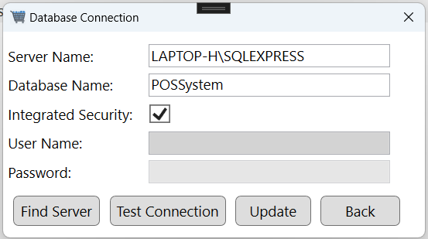

After installing Microsoft SQL Server and setting up the database ensure the server name, database name and method of connecting is correctly supplied. I my case I have a local instance of SQL Server running so I have integrated security checked. You can use the Find Server button to detect any local instances of SQL Server. Additionally make use of the Test Connection button to ensure the supplied details are valid.

### Exit

Will exit the program.

## Login

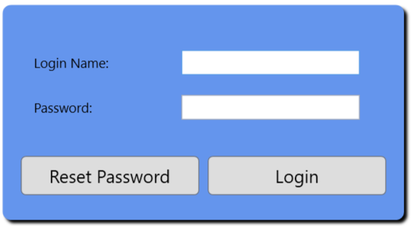

### Reset Password

Type in the Login Name and Click on the Reset Password Button

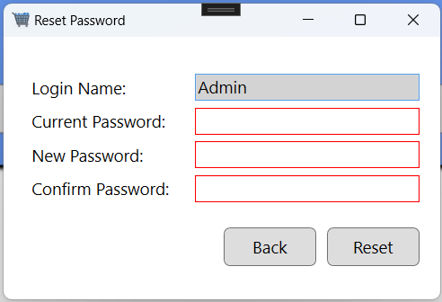

### Login

If you used the POSSystem.bak backup file my default account can be used to login

User: Admin; Password: 123456

# POS System (Menu Bar)

## Options

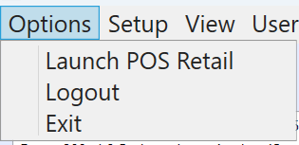

### Launch POS Retail

This will open the Point of Sale where the cashier can capture sales.

### Logout

This will log the current user out of the system.

### Exit

This will exit the user from the program.

## Setup

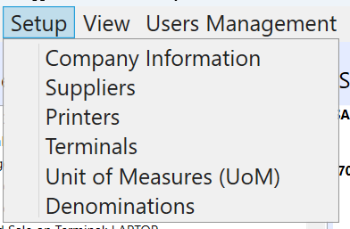

### Company Information

This is where you can setup the basic information of your business.

### Suppliers

This is where you can setup the basic information of suppliers.

#### Add Supplier

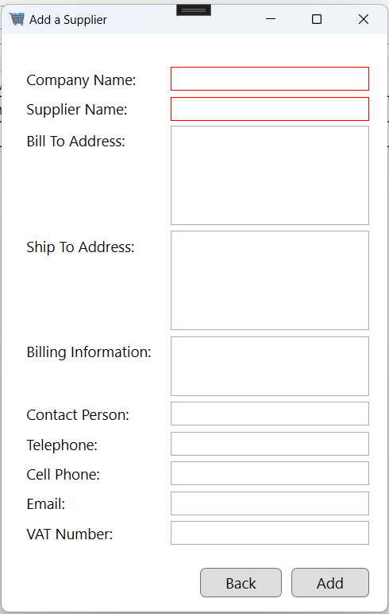

#### Update Supplier

#### Remove Supplier

### Printers

This is where you can setup printers for till slips

#### Add Printer

#### Update Printer

#### Remove Printer

### Terminals

This is where you can setup Terminals to be used for the Point of Sale computers. (Front of Store)

#### Add Terminal

#### Update Terminal

### Unit of Measures

#### Add UoM

#### Update UoM

### Denominations

This is where you can setup your countries denominations.

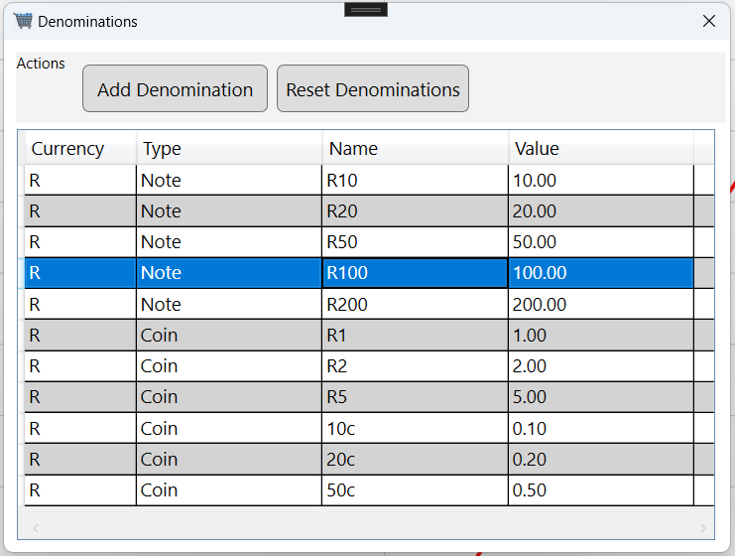

#### Add Denomination

#### Reset Denominations

Can only be done if no sales have been made.

## View

### History Log

This is a tracking view of everything important that happens in the system, there are multiple filters to make use of.

#### Options -> Export to Excel

You can export the data to excel.

## User Management

### Users

This is where you can create users for the system.

The Pin is what the cashier will use to log into the Point of Sale.

#### Add User

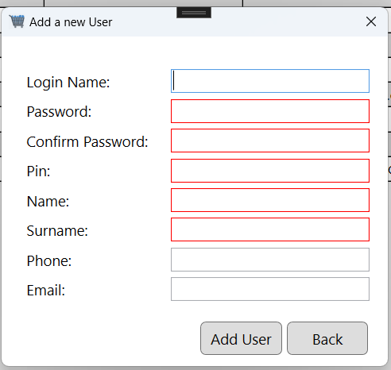

#### Update User

#### Active/Inactive

#### Reset Password

### Security

Here you can create a role group and link users and system objects to the role group.

#### Add Role Group

#### Update Role Group

## Stock Management

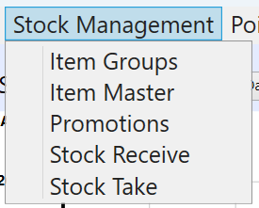

### Item Groups

This is where Item Group can be created to manage inventory more efficiently.

#### Add Item Group

#### Update Item Group

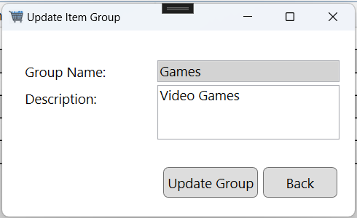

### Item Master

This is where all products are created and managed.

#### Options

Here you can export all products to excel.

#### Add Item -> Item Setup

Basic Item information including price and quantity limits

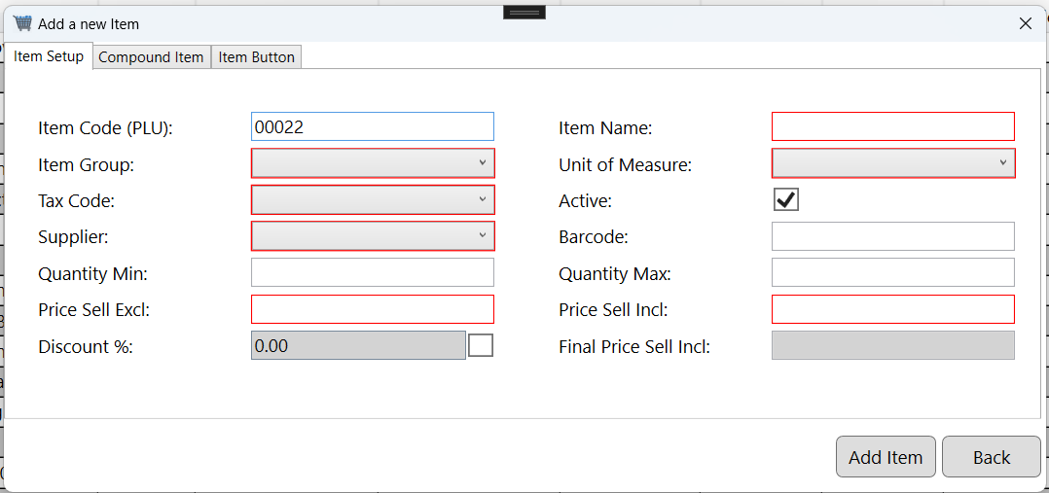

#### Add Item -> Compound Item

This is where you can create a Item that contains other items (Example: six pack drink contains 6 induvial drinks)

#### Add Item -> Item Button

This is where the Items’ button can be customized that will be used on the Point of Sale

### Update Item

This action updates all of the products information.

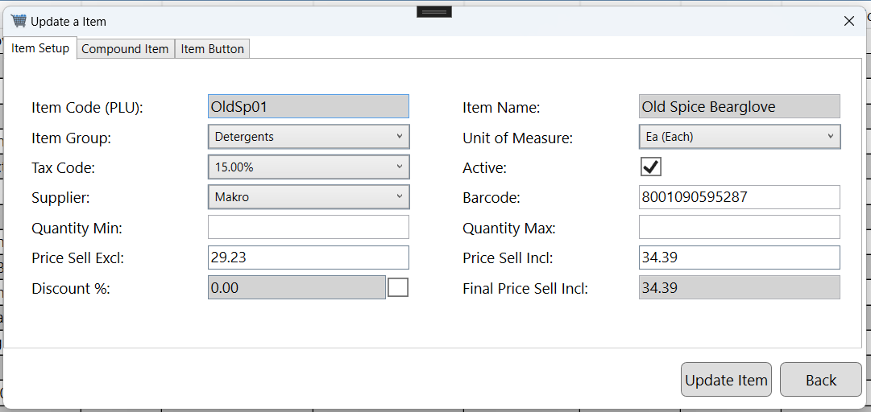

### Promotions

This feature is incomplete.

### 

### Receive Stock

This is where stock for items can be viewed.

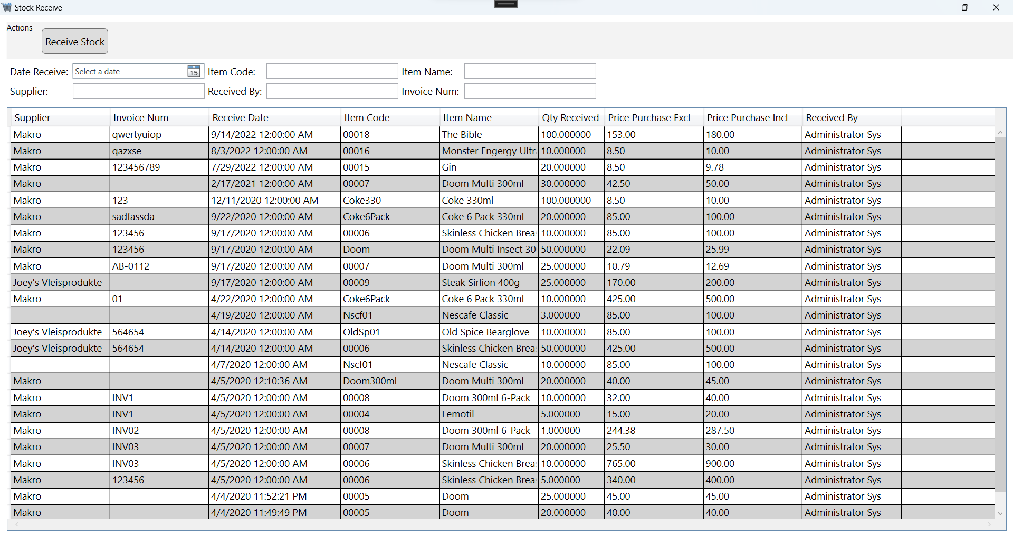

#### Receive Stock Button

This is where new stock can be captured.

### Stock Take

This is where you can count stock in store.

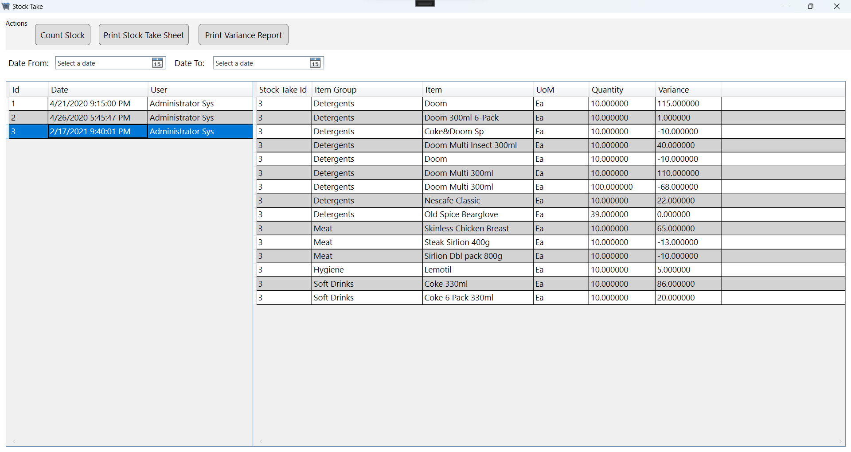

#### Count Stock Button

## Point of Sale

### Sales History

This is a view of all sales made

#### Item Column Button

This will show the buttons on the Sale.

### Sales Return

This feature is incomplete.

## Shifts

This is where Shift are created for a cashier

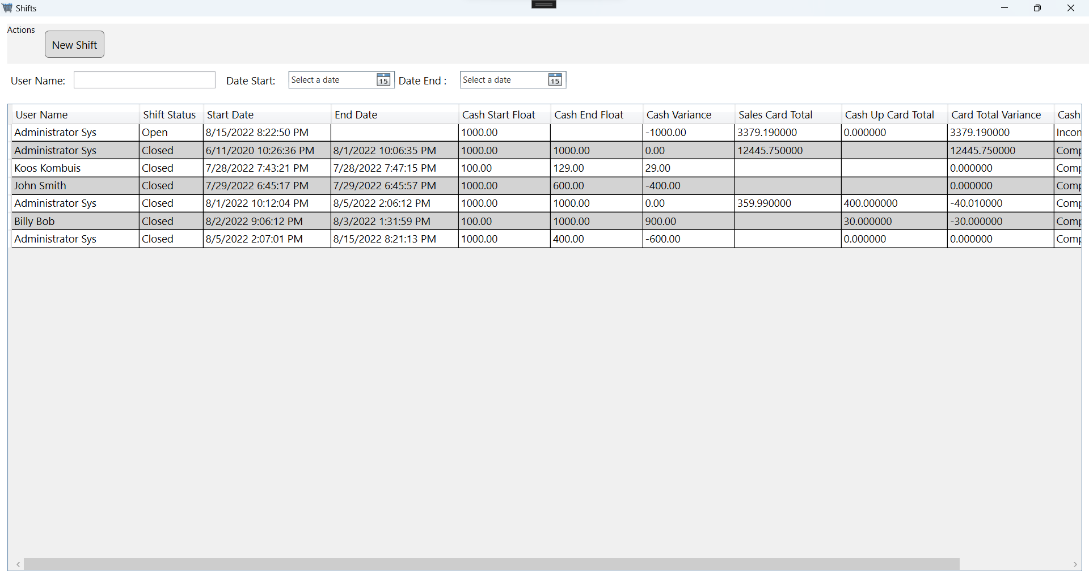

#### New Shift

#### End Shift

## Cash Up

After the shift has been completed the money needs to be counted.

# POS System (Messages)

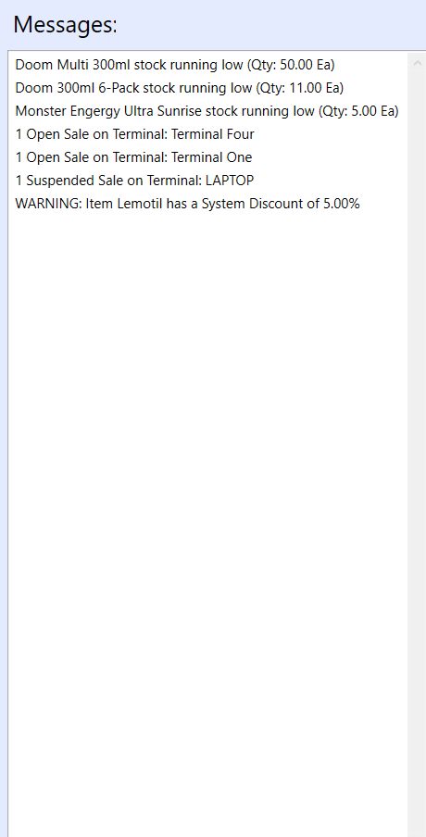

# POS System (Sales History Graph)

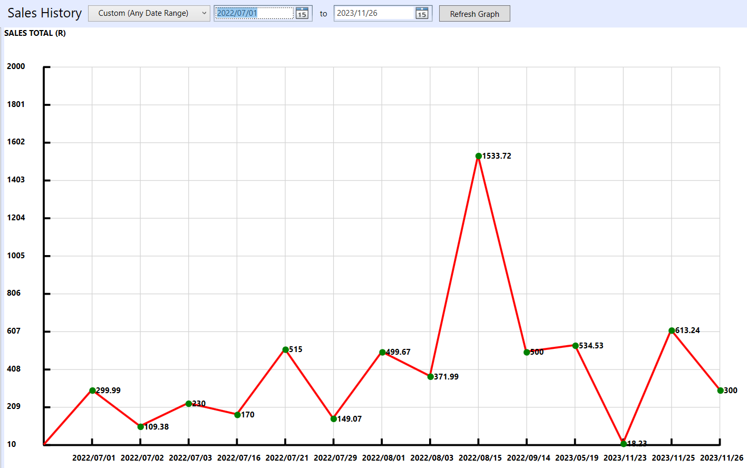

# Point of Sale (Retail)

Login with PIN

# POS Main Screen

This is where the Cashier will process sales.

